## **Lab 17: Android Tween Animation**

# **Introduction**

Animation is a technique that turns a group of still images into moving ones by combining them in a specific way and processing them. Building animations provide the appearance that items on screen are living. There are many tools available on Android that can help you make animations quite quickly.

**Let’s get Started:**

In this example, we are implementing tween animation in an Android App using Kotlin.

**Step 1:** open **activity_main.xml** file from **\res\layout** folder path and write the code like as shown below.

**activity_main.xml**

*<?*xml version="1.0" encoding="utf-8"*?>*<RelativeLayout xmlns:android="http://schemas.android.com/apk/res/android"  
 xmlns:tools="http://schemas.android.com/tools"  
 android:layout_width="match_parent"  
 android:layout_height="match_parent"  
 tools:context=".MainActivity">  
 <TextView  
 android:id="@+id/textView"  
 android:layout_width="match_parent"  
 android:layout_height="match_parent"  
 android:layout_above="@+id/linearLayout"  
 android:gravity="center"  
 android:text="Hello Snapchat!"  
 android:textColor="#FBC02D"  
 android:textSize="32sp"  
 android:textStyle="bold" />  
 <LinearLayout  
 android:id="@+id/linearLayout"  
 android:layout_width="match_parent"  
 android:layout_height="wrap_content"  
 android:layout_alignParentBottom="true"  
 android:orientation="vertical">  
 <LinearLayout  
 android:layout_width="match_parent"  
 android:layout_height="wrap_content"  
 android:orientation="horizontal"  
 android:weightSum="2">  
 <Button  
 android:id="@+id/fade_in"  
 android:layout_width="0dp"  
 android:layout_height="match_parent"  
 android:layout_weight="1"  
 android:text="Fade In"  
 android:textAllCaps="false" />  
 <Button  
 android:id="@+id/fade_out"  
 android:layout_width="0dp"  
 android:layout_height="match_parent"  
 android:layout_weight="1"  
 android:text="Fade Out"  
 android:textAllCaps="false" />  
 </LinearLayout>  
 <LinearLayout  
 android:layout_width="match_parent"  
 android:layout_height="wrap_content"  
 android:orientation="horizontal"  
 android:weightSum="2">  
 <Button  
 android:id="@+id/zoom_in"  
 android:layout_width="0dp"  
 android:layout_height="match_parent"  
 android:layout_weight="1"  
 android:text="Zoom In"  
 android:textAllCaps="false" />  
 <Button  
 android:id="@+id/zoom_out"  
 android:layout_width="0dp"  
 android:layout_height="match_parent"  
 android:layout_weight="1"  
 android:text="Zoom Out"  
 android:textAllCaps="false" />  
 </LinearLayout>  
 <LinearLayout  
 android:layout_width="match_parent"  
 android:layout_height="wrap_content"  
 android:orientation="horizontal"  
 android:weightSum="2">  
 <Button  
 android:id="@+id/slide_down"  
 android:layout_width="0dp"  
 android:layout_height="match_parent"  
 android:layout_weight="1"  
 android:text="Slide Down"  
 android:textAllCaps="false" />  
 <Button  
 android:id="@+id/slide_up"  
 android:layout_width="0dp"  
 android:layout_height="match_parent"  
 android:layout_weight="1"  
 android:text="Slide Up"  
 android:textAllCaps="false" />  
 </LinearLayout>  
 <LinearLayout  
 android:layout_width="match_parent"  
 android:layout_height="wrap_content"  
 android:orientation="horizontal"  
 android:weightSum="2">  
 <Button  
 android:id="@+id/bounce"  
 android:layout_width="0dp"  
 android:layout_height="match_parent"  
 android:layout_weight="1"  
 android:text="Bounce"  
 android:textAllCaps="false" />  
 <Button  
 android:id="@+id/rotate"  
 android:layout_width="0dp"  
 android:layout_height="match_parent"  
 android:layout_weight="1"  
 android:text="Rotate"  
 android:textAllCaps="false" />  
 </LinearLayout>  
 </LinearLayout>  
</RelativeLayout>

**Step 2:** Open main [activity](https://www.tutlane.com/tutorial/android/android-activity-lifecycle) file **MainActivity.kt** and write the code like as shown below.

**MainActivity.kt**

**package** com.example.demopluralsighttweenanimation  
**import** android.os.Bundle  
**import** android.os.Handler  
**import** android.support.v7.app.AppCompatActivity  
**import** android.view.View  
**import** android.view.animation.AnimationUtils  
**import** android.widget.Button  
**import** android.widget.TextView  
  
**class** MainActivity : AppCompatActivity() {  
 **override fun** onCreate(savedInstanceState: Bundle?) {  
 **super**.onCreate(savedInstanceState)  
 setContentView(R.layout.*activity_main*)  
 **val** fade_in:Button  
 **val** fade_out:Button  
 **val** zoom_in:Button  
 **val** zoom_out:Button  
 **val** slide_up:Button  
 **val** slide_down:Button  
 **val** bounce:Button  
 **val** rotate:Button  
 **val** textView:TextView  
 fade_in=findViewById(R.id.*fade_in*)  
 fade_out=findViewById(R.id.*fade_out*)  
 zoom_in=findViewById(R.id.*zoom_in*)  
 zoom_out=findViewById(R.id.*zoom_out*)  
 slide_up=findViewById(R.id.*slide_up*)  
 slide_down=findViewById(R.id.*slide_down*)  
 bounce=findViewById(R.id.*bounce*)  
 rotate=findViewById(R.id.*rotate*)  
 textView=findViewById(R.id.*textView*)  
  
 fade_in.setOnClickListener **{** textView.*visibility* = View.*VISIBLE* **val** animationFadeIn = AnimationUtils.loadAnimation(**this**, R.anim.*fade_in*)  
 textView.startAnimation(animationFadeIn)  
 **}** fade_out.setOnClickListener **{  
 val** animationFadeOut = AnimationUtils.loadAnimation(**this**, R.anim.*fade_out*)  
 textView.startAnimation(animationFadeOut)  
 Handler().postDelayed(**{** textView.*visibility* = View.*GONE* **}**, 1000)  
 **}** zoom_in.setOnClickListener **{  
 val** animationZoomIn = AnimationUtils.loadAnimation(**this**, R.anim.*zoom_in*)  
 textView.startAnimation(animationZoomIn)  
 **}** zoom_out.setOnClickListener **{  
 val** animationZoomOut = AnimationUtils.loadAnimation(**this**, R.anim.*zoom_out*)  
 textView.startAnimation(animationZoomOut)  
 **}** slide_down.setOnClickListener **{  
 val** animationSlideDown = AnimationUtils.loadAnimation(**this**, R.anim.*slide_down*)  
 textView.startAnimation(animationSlideDown)  
 **}** slide_up.setOnClickListener **{  
 val** animationSlideUp = AnimationUtils.loadAnimation(**this**, R.anim.*slide_up*)  
 textView.startAnimation(animationSlideUp)  
 **}** bounce.setOnClickListener **{  
 val** animationBounce = AnimationUtils.loadAnimation(**this**, R.anim.*bounce*)  
 textView.startAnimation(animationBounce)  
 **}** rotate.setOnClickListener **{  
 val** animationRotate = AnimationUtils.loadAnimation(**this**, R.anim.*rotate*)  
 textView.startAnimation(animationRotate)  
 **}** }  
}

**Step 3: Check Output on Android Emulator and it should look like as given below.**

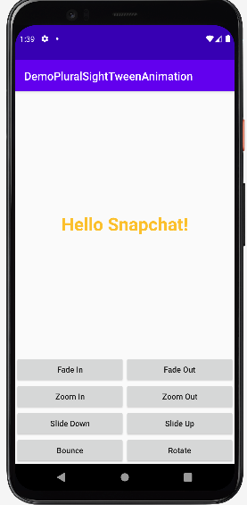 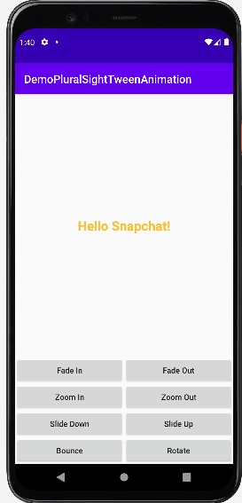

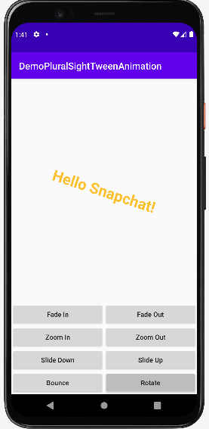 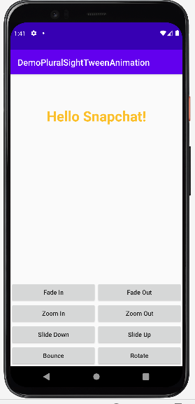

**Voila!!** We have successfully completed this lab.